BSC (Hons) International Hospitality Management
Computing Infrastructure (Linux
essentials)
SWE4303
2526787
Michail Sideris
Kyriaki Saiti
15/1/2026

• Task 1 — System Preparation
For the automation a good directory structure was used. The scripts, logs, backup and doc files were stored in their individual directories. My step by step approach makes my process clearer, helps maintain it well and is consistent and serves as a nice and conducive environment
mkdir -p ~/admin_automation/{scripts,logs,backups,documentation}
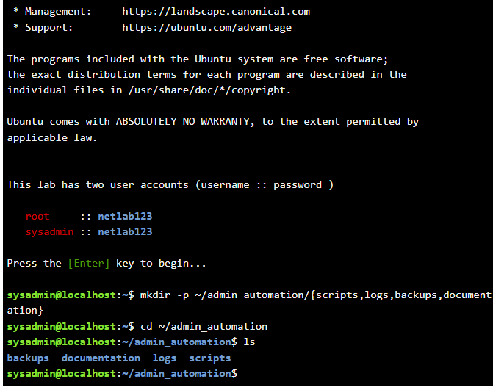

• Task 2 — User & Group Automation
User accounts are created automatically with a Bash script that reads usernames from an external text file. Each entry goes through a series of operations and then a user account including their home directory is created. This way both stability in treatment as well as minimum manual effort can be achieved for users.
nano users.txt
CEO
SalesDirector
ITAdmin
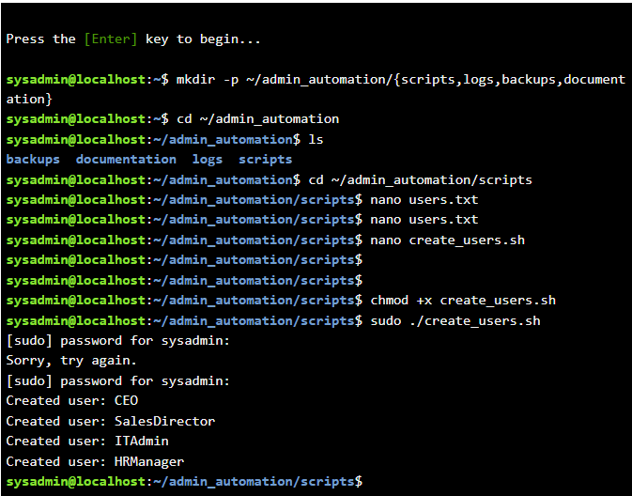
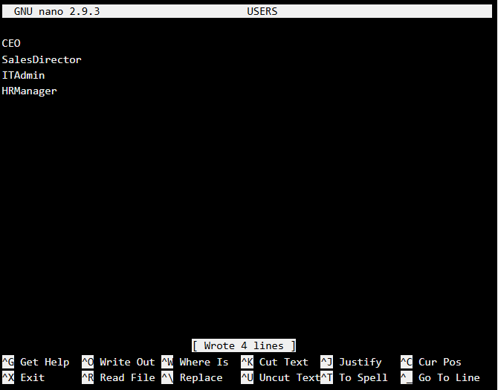
HRManager

nano create_users.sh
#!/bin/bash
FILE=~/admin_automation/scripts/users.txt

while read USER; do
if id "$USER" &>/dev/null; then
echo "User $USER already exists"
else
sudo useradd -m "$USER"
echo "Created user: $USER"
fi
done < "$FILE"
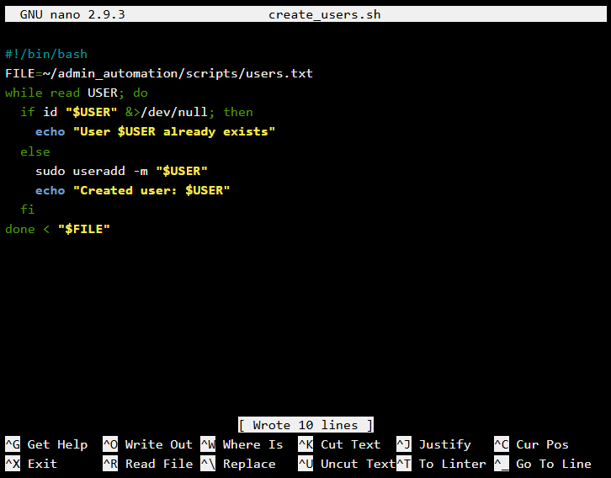

User categories were established to enable relevant user groups to access shared resources. Then I created numerical permissions for files and directories to limit access to users only and to improve security.

sudo groupadd Salesteam # this command will create a group with name Salesteam
sudo usermod -aG Salesteam SalesDirector # this command will add user to group
sudo mkdir /shared # this command will create a shared directory
sudo chown root:Salesteam /shared # this command will set owner and group of folder
sudo chmod 770 /shared # this command will set permission

(#Owner: 7 -> read (4), write(2), execute(1)
Group:7
Other: 0 -> no access to other users (not in groups))

• Task 3 — Backup & File System Administration
A backup plan was created by making use of compression utilities to archive the contents of the /home directory. To do so, backup files were made along with date data so that many backups could be made automatically. Backup operations were tracked in log files at predetermined times by cron for automatic backup running.
nano backup.sh
#!/bin/bash
tar -czf ~/admin_automation/backups/home_$(date +%F).tar.gz /home
echo "Backup created on $(date)" >> ~/admin_automation/logs/backups.log
crontab – e(0 2 * * * /home/michail/admin_automation/scripts/backup.sh)

#crontab -e
#I -> insert text
#Esc->exit insert text mode
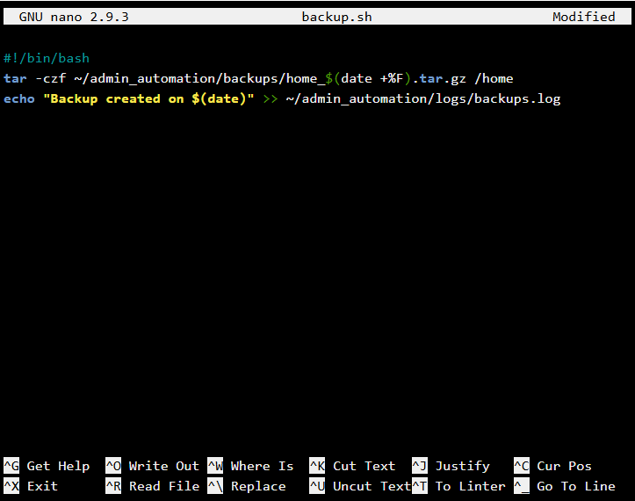
#:wq -> save and exit
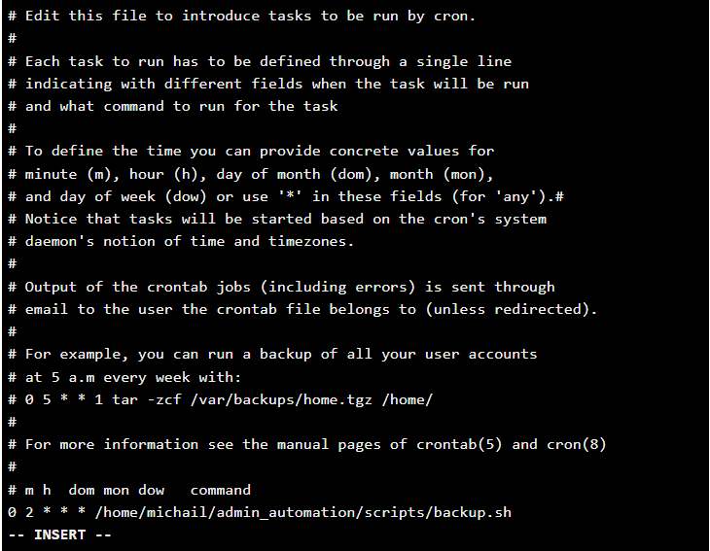

#tar (archive utility)
#c – create new archive
#z - compress with gzip
#v – verbose (show files being processed)
#f – filename follows
#date current time and date
#date +%F -> the next day after the current day # today is 10.12.2025, date + %F: 11.12.2025
#date +%T -> the time after the current time (if now is 2:06:01, date +%T: 3:06:01)
# we use the cron (cron job) to automate the backup

• Task 4 — System Monitoring Automation
Automated monitoring scripts managed to monitor the accuracy of the system, such as processor usage performance, memory capacity and disk capability. The data that can be gathered to use is saved in logs to give admins historical records that may provide usefull to identify possible performance issues, so that systems can continue to be up and running.
nano system_monitor.sh
#!/bin/bash
LOGFILE=~/admin_automation/logs/system_monitor.log
echo "System Report - $(date)" >> $LOGFILE
echo "CPU: $(top -bn1 | grep 'Cpu(s)')" >> $LOGFILE
free -h >> $LOGFILE
df -h >> $LOGFILE
echo "" >> $LOGFILE
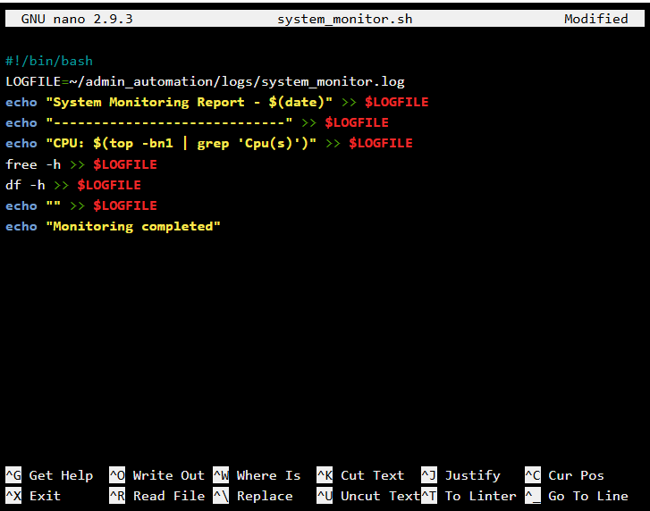
echo "Monitoring completed"
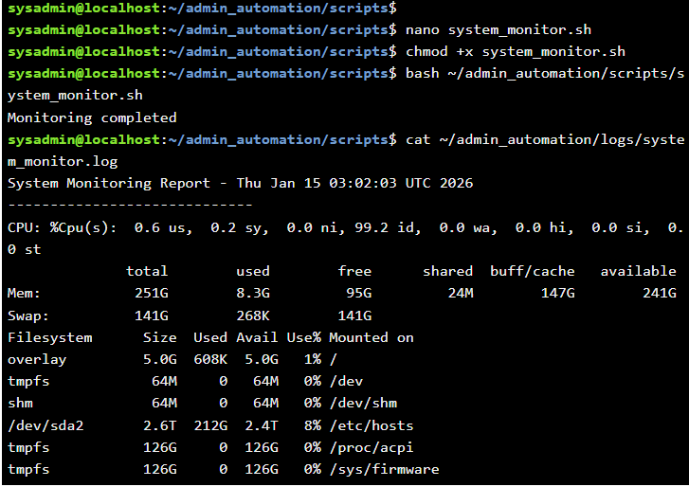

• Task 5 — Network Health Checks
The network functionality was checked through an automated program that tested with external hosts to see how connected the network really was. After recording these tests, administrators could swiftly determine failures from them, responding quickly.
network_check.sh
#!/bin/bash
SERVER="127.0.0.1"
LOGFILE=~/admin_automation/logs/network_check.log
ping -c 3 $SERVER > /dev/null
if [ $? -eq 0 ]; then
echo "$(date): Network OK" >> $LOGFILE
else
echo "$(date): Network ERROR" >> $LOGFILE
fi
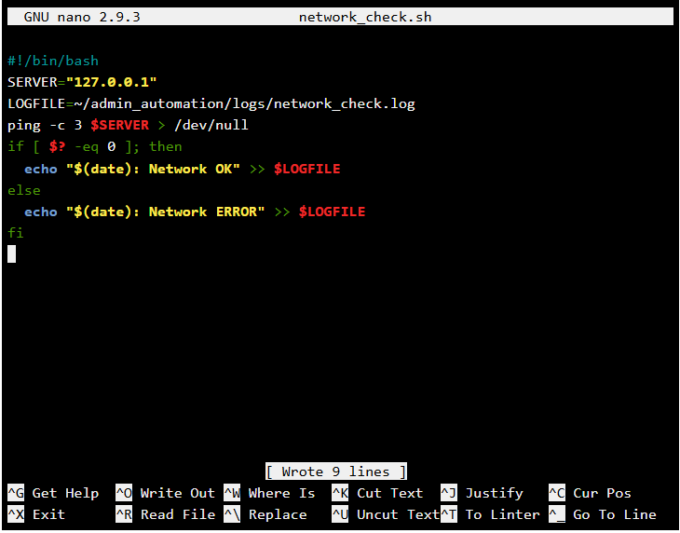

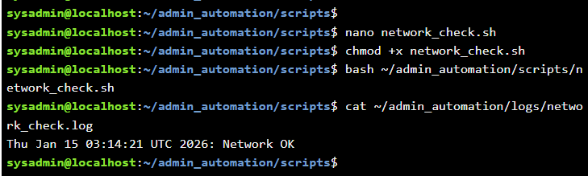

• Task 6 — Bash Customization
For the Bash shell environment I also improved the comfort level through aliases.
nano ~/.bashrc # I open the bash configuration file
alias ll='ls -lah' #creating an allias aka shortcut command

# ls -lah means:
# ls -> list files
# -l -> long format (permissions, owner, size)
# -a -> show hidden files
# -h -> human-readable sizes

PS1='\u@\h:\w$ ' #this controls how the terminal propt will look like
# \u -> username
# @ -> literal @ symbol
# \h -> hostname or server name
# : -> separator
# \w -> current working directory
# $ -> prompt symbol

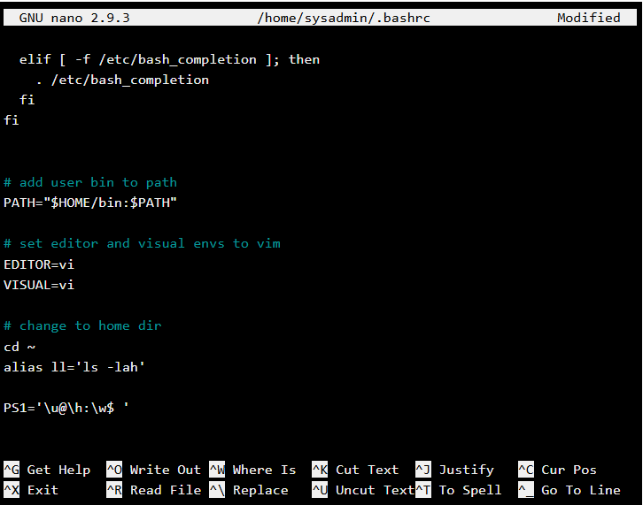

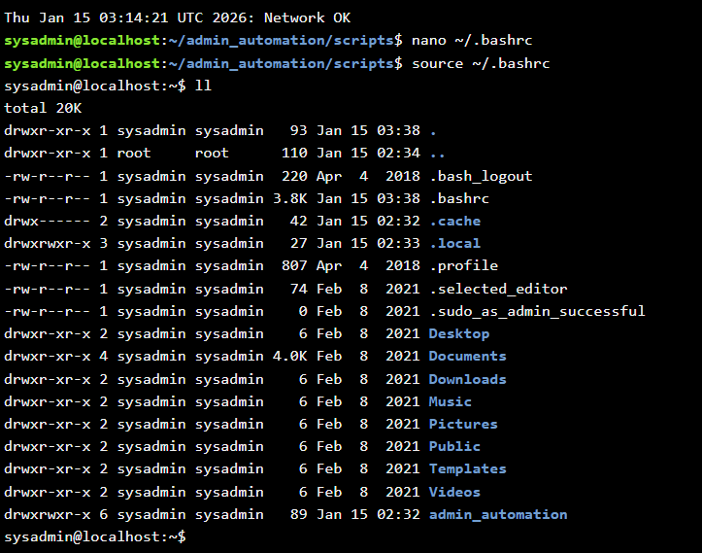

• Task 7 — Admin Toolkit Menu
I have also constructed an interface that employs menus. I designed that administrative interface so the automation script is going to run on the administrators’ desktop. When the administrators want to make changes, the automation script shows on the administrators’ desktop. The dynamic operating directory does not change executions I have learnt so far. I use path in the dynamic version of the operating directory to ensure an execution being done is consistent.
nano admin_menu.sh
#!/bin/bash
while true; do
echo "=========================="
echo " ADMIN AUTOMATION TOOLKIT "
echo "=========================="
echo "1. Create Users"
echo "2. System Monitoring"
echo "3. Network Check"
echo "4. Run Backup"
echo "5. Exit"
read -p "Choose an option: " CHOICE
case $CHOICE in
1) bash ~/admin_automation/scripts/create_users.sh ;;

2) bash ~/admin_automation/scripts/system_monitor.sh ;;
3) bash ~/admin_automation/scripts/network_check.sh ;;
4) bash ~/admin_automation/scripts/backup.sh ;;
5) exit ;;
*) echo "Invalid option" ;;
esac
done
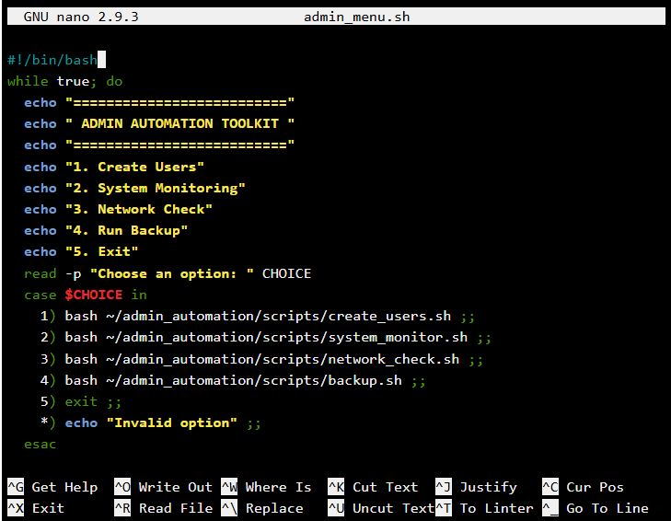

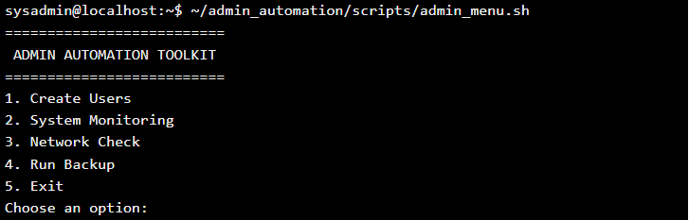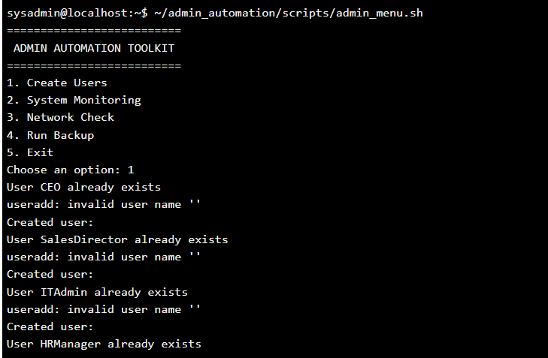

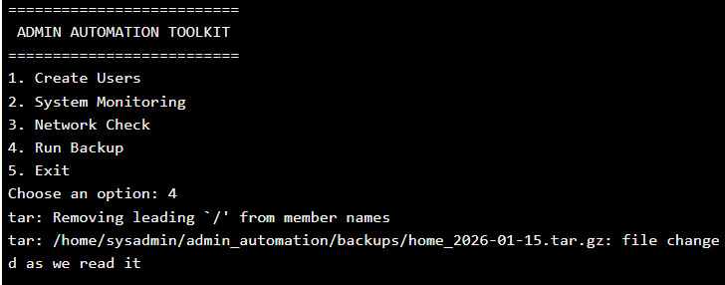
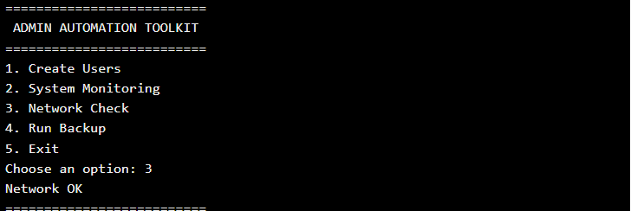
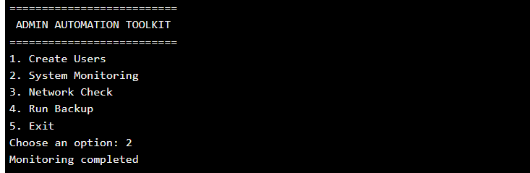

• Task 8 — Documentation
An explanation for the automation toolkit why it was developed, the format of the directory, and how to use it and guidance for operating it was put together in documentation. This documentation enables maintainability which allows the system to be intelligible and feasible for future administrators.
nano README.md
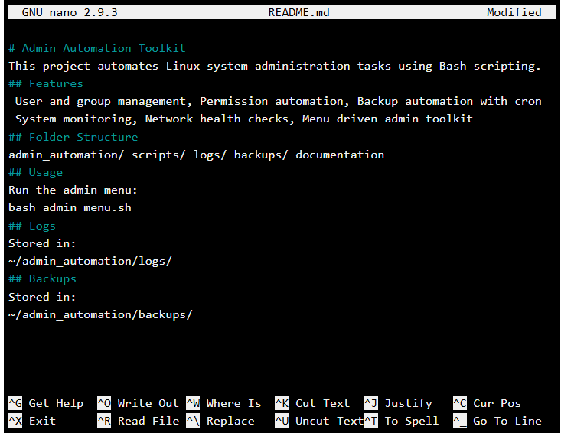

USE OF GAI
ChatGPT was used as a Generative Artificial Intelligence solution to help structure scripts, validate Linux commands, and improve clarity of explanations. The student reviewed, tested and adapted all generated content. No content is presented without understanding or verification

Declaration of Software Tools Used
Linux Ubuntu (Cisco VM)
Bash Shell
Nano Text Editor
Cron
ChatGPT (GAI – acknowledged)

References
Class Notes
Cisco Networking Academy(Linux Essentials Course)
The Linux Programming Interface: A Linux and UNIX System Programming(Michael Kerrisk)
How Linux Works: What Every Superuser Should Know(Brian Ward)
Linux Pocket Guide: Essential Commands(Daniel J. Barrett)

Advanced Programming in the UNIX Environment(Sir Richard W. Stevens)
The Linux Command Line: A Complete Introduction(William Shotts)

